

**The Egyptian e-Learning University**

**Faculty of Computers and Information Technology**

**Tailored Educational System**

Graduation Project Documentation

Team members:

|  |  |
| --- | --- |
| Hosny Hany Hammad | 20-01560 |
| Amr Mosely Maher | 20-00093 |
| Hadir Maher El Sayed | 20-00113 |
| Bassant Hassib | 20-01463 |
| Basmala Ahmed Ali | 20-01545 |
| Asmaa Abdeldayem Wasel | 20-01586 |
| Yara Hazem Zahra | 20-01432 |
| Nada Mohamed Saleh | 20-00204 |

Supervised by:

**Prof. Mohamed Ashor**

**Eng. Amal Ghoneim**

# Abstract

This System is concerned with learning, and this helps people get learning in an easy way and the user can choose the suitable track for him, we all know that AI made learning easy for all users from all over world, so we use AI in this system. use this system to know any information that is relevant about any track. It is also designed to provide the user with information about how to start learning from zero until becoming hero in the track. The system aims to educate users about the many tracks, The user can tell the chatbot his skills and the chatbot replies to him. The chatbot replies to the user by a lot of data the boot was training. The app features a user-friendly interface that allows users to easily navigate through the different sections, including rood maps, chatbot to choose my track and search about a question.

The project of tailored educational system involves the analysis of a comprehensive dataset of various question, we have collected the data set from the many websites to have a large dataset through which we can classify the question and choose the suitable track for users to learn by using Machine learning algorithms. These algorithms can be trained on large datasets to learn to benefit the users by choosing the suitable track for each user and answer to any question belonging to the learning such as: "How make API “, “How make Recycler view “.

We have a lot of ambitions to develop the project after graduation. We will collect a large amount of data and add it to the dataset and increase the accuracy, and we develop the application so that it works on more types of question, and we can Sign Up with (google, Facebook, Twitter, etc..). In the future we hope that our application can be used worldwide in many different languages (Arabic, French, etc..).

**Keywords**

Machine learning, Python, Kotlin, Android, (NLP), Firebase, Frontend, Json, Flask.

**Contents**

**Abstract.........................................................................................**

**Keywords......................................................................................**

**List of Abbreviations...................................................................**

**List of fingers................................................................................**

**Introduction............................................................................**

**1.2 Problem Statement........................................................**

**1.3 NLP..............................................................................**

**1.4 Advantages of NLP......................................................**

**1.5 Disadvantages of NLP.................................................**

**1.5.1 Ambiguity and Context Understanding..................................................**

**1.5.2 Data Quality and Bais...............................................................................**

**1.5.3 Lack of Common-Sense Understanding..................................**

**Planning and analysis.........................................................**

**Background / Related Work..................................................**

**2.1 Machine Learning.................................................................**

**2.2 NLP........................................................................**

**2.3 Problems..................................................................................**

**Collection and employing data.........................................................**

**3.1 Collect Data........................................................**

**3.2 We collected the data in these tracks.............................................................**

**3.3 The data collected for two Functions are......................................................**

**3.3.1 The data collected in the Android Track.........................................**

**3.3.2 The data collected in the flutter Track............................................**

**3.3.3 The data collected in the back-end Track..................................**

**3.3.4 The data collected in the Ai and Data science Track.................**

**3.3.5 The data collected in the full stack Track..................................**

**3.3.6 The data collected in the front-end Track................................**

**3.3.7 The data collected in the Ui/Ux Track..............................**

**Proposed System.........................................................**

**4.1 Main core of the project........................................................**

**4.2 Chatbots and Virtual Assistants.............................................................**

4.**2.1 Supervised Classification......................................................**

**4.2.1.1 Data Collection and Preprocessing............................................**

**4.2.1.2 Feature Extraction with NLP...............................................**

**4.2.1.3 Training the Model..............................................................**

**4.2.1.4 Integration into Chatbot........................................................**

**4.2.1.5 Response Generation..........................................................**

**4.2.2 Unsupervised Classification.....................................................**

**4.2.2.1 Clustering Techniques...................................................**

**4.2.2.2 Word Embeddings and Similarity Measures.............**

**4.2.2.3 Anomaly Detection.........................................................**

**4.2.2.4 Response Generation or Routing.............................**

**4.2.2.5 Continuous Learning and Improvement....................**

**4.2.3 Structure for performing NLP in chatbots................................**

**4.2.3.1 Text Preprocessing.......................................................................**

**4.2.3.2 Intent Recognition and Entity Extraction...................................**

**4.2.3.3 Dialog Management..............................................................**

**4.2.3.4 Natural Language Understanding (NLU) Models....................**

**4.2.3.5 Context Handling and Memory............................................**

**4.2.3.6 Sentiment Analysis (Optional)...........................................**

**4.2.3.7 Integration and Deployment..........................................**

**4.2.3.8 Tools and Libraries...............................................................**

**4.2.4 Choosing from the deep learning Algorithms...............................**

**4.2.4.1 Training the model Clustering Algorithms(unsupervised)..........**

**4.3 Machine Learning types..................................................**

**4.3.1 Supervised Learning.......................................................**

**4.3.2 Unsupervised Learning................................................**

**4.3.3 Semi-supervised Learning...............................**

**4.3.4 Reinforcement Learning..................**

**Our App.............................................................................**

**5.1 Sign in Page..................................................................**

**5.2 Sign-up Page..............................................................**

**5.3 About Page...................................................................**

**5.4 Info Page........................................................**

**5.5 Contact Page......................................................................**

**Result and Discussion...............................................**

**5.2.1 Trello......................................................................**

**5.2.2 Splash Screen...................................................................**

**5.2.3 Register Screen.................................................................**

**5.2.4 Sign in Screen..................................................................**

**5.2.5 Home Screen.................................................................**

**5.2.6 Rood Maps Screen............................................................**

**5.2.7 Chat Screen......................................................................**

**5.2.8 Settings Screen................................................................**

**5.2.9 Info Screen.....................................................................**

**5.2.10 Account Screen................................................................**

**Conclusion and Future work..................................................................**

6**.1 Conclusion..........................................................................................**

**6.2 Future Work..............................................................................................**

**References.....................................................................................**

# List of Abbreviations

**AI**  Artificial Intelligence

**ML** Machine Learning

**NLP** Natural language processing

**Chapter one**

# Introduction

The Tailor Educational System Mobile Application is a groundbreaking tool developed to assist users How to start learning, what is the suitable track, and help user by provide him information belong to the learning. Harnessing the power of machine learning, this application offers a user-friendly interface that made user learning by easy way and enables him timely to get any information belonging to the learning. With a focus on convenience and efficiency, the application allows users to search for any information that belongs to the learning and can chat to the chatbot by sending his skills and the boot can tell him about the suitable track for him to learn and allow users to see all the rood maps and collecting much information about any track to learn how start until become hero in the track. This data is processed using Natural Language processing algorithms. By automating the data analysis process, the application saves time and effort while ensuring accurate search and reply for any question. At the heart of The Tailor Educational System Mobile Application is a machine learning model, this model is built using Natural language processing (NLP) which is a branch of [artificial intelligence (AI)](https://www.oracle.com/eg/artificial-intelligence/what-is-ai/) that enables computers to comprehend, generate, and manipulate human language. Natural language processing has the ability to interrogate the data with natural language text , NLP is what enables them to not only understand the user’s request, but to also respond in natural language , and this help us in our app to make an interactive chatbot using NLP to answer users using data set to train model The Tailor Educational System Mobile Application is designed with scalability and continuous improvement in mind. Regular updates to the question recognition model, based on user feedback and the latest research findings, ensure the application remains up to date and capable of accurately detecting emerging questions. With its user-friendly interface, comprehensive learning information, and data management capabilities, The Tailor Educational System Mobile Application serves as a valuable tool for users who want to learn, researchers, and enthusiasts. The application contributes to saving time and effort and not distracting students' thoughts.

## Problem statement

* The problem of choosing the track is a major concern for the students around the world.
* Many students face the problem of learning many topics to do something simple.
* Many students fall into confusion to choose the suitable track for them.
* Knowing the answer of How to build it through learning how to build it, searching about the any question belong to programming have become take much time and effort and Distracting students' thoughts.

## 1.3 NLP

Natural Language Processing (NLP) is a field of artificial intelligence (AI) that focuses on enabling computers to understand, interpret, and generate human language in a valuable and meaningful way. It involves the interaction between computers and humans using natural language.

## 1.4 Advantages of NLP

NLP enables more natural and intuitive communication between humans and machines, leading to the development of chatbots, virtual assistants, and voice interfaces that can understand and respond to user queries.

NLP techniques allow the extraction of structured information from unstructured text data, facilitating tasks like entity recognition, summarization, and information retrieval from large text corpora.

NLP tools can analyze and classify text sentiments, enabling businesses to gauge public opinion, customer feedback, and social media sentiments. This helps in brand monitoring, reputation management, and understanding user preferences.

## 1.5 Disadvantages of NLP

**Ambiguity and Context Understanding:** Language can be highly ambiguous, with multiple meanings for words or phrases depending on the context. Capturing and understanding context accurately remains challenging for NLP models.

**Data Quality and Bias:** NLP models heavily rely on the quality and quantity of data. Biases present in the training data (e.g., gender or racial biases) can be perpetuated by the models, leading to unfair or skewed predictions

**Lack of Common-Sense Understanding:** NLP models often struggle with common-sense reasoning and understanding implicit knowledge that humans take for granted. They may fail in tasks requiring inference or reasoning beyond the explicit text.

**Chapter Two**

**Planning and analysis**

**Project plane:**

* **Functional Requirements:**
* **Rood Maps**
* **Search About a Question**

Learning Assistance:

The application assists users in starting their learning journey by providing information on suitable tracks.

Search Functionality:

Users can search for any information related to learning.

Chatbot Interaction:

Users can engage with a chatbot, providing their skills for personalized learning track recommendations.

Roadmap Access:

Users can access roadmaps for various learning tracks.

Data Collection:

Users can collect detailed information about any chosen learning track, facilitating a comprehensive understanding of the learning process.

Machine Learning Model:

The application employs a machine learning model based on Natural Language Processing (NLP) to comprehend and respond to user queries.

Continuous Improvement:

Regular updates to the question recognition model are implemented based on user feedback and the latest research findings.

* **Non-Functional Requirements:**

User-Friendly Interface:

The application provides a user-friendly interface to enhance the ease of learning for users.

Efficiency:

Focuses on convenience and efficiency, ensuring timely access to information and minimizing user effort.

Data Processing Efficiency:

Automates data analysis using NLP algorithms, saving time and effort while providing accurate responses to user queries.

Scalability:

The application is designed with scalability in mind, accommodating growth in users and data over time.

Accuracy:

The machine learning model is designed to provide accurate responses, ensuring reliability in information about learning tracks.

User Engagement:

The interactive chatbot and features contribute to user engagement, making the learning experience dynamic and personalized.

Continuous Improvement:

The application is designed for continuous improvement, adapting to emerging questions and staying up to date with the latest advancements.

Distraction Minimization:

Aims to minimize distractions, allowing users to focus on their educational journey without unnecessary interruptions.

* **Flow Chart Diagram:**

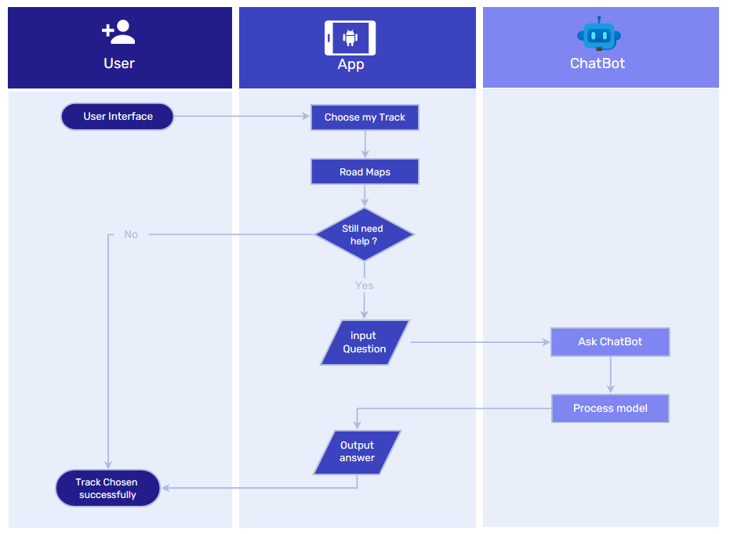

* **Use case:**

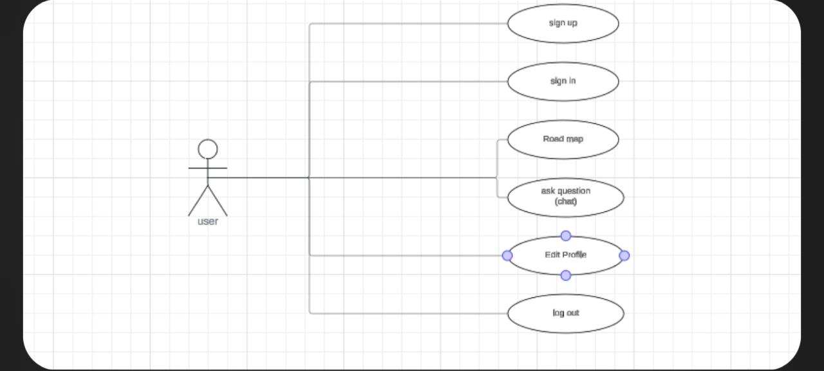

* **UML Class Diagram:**

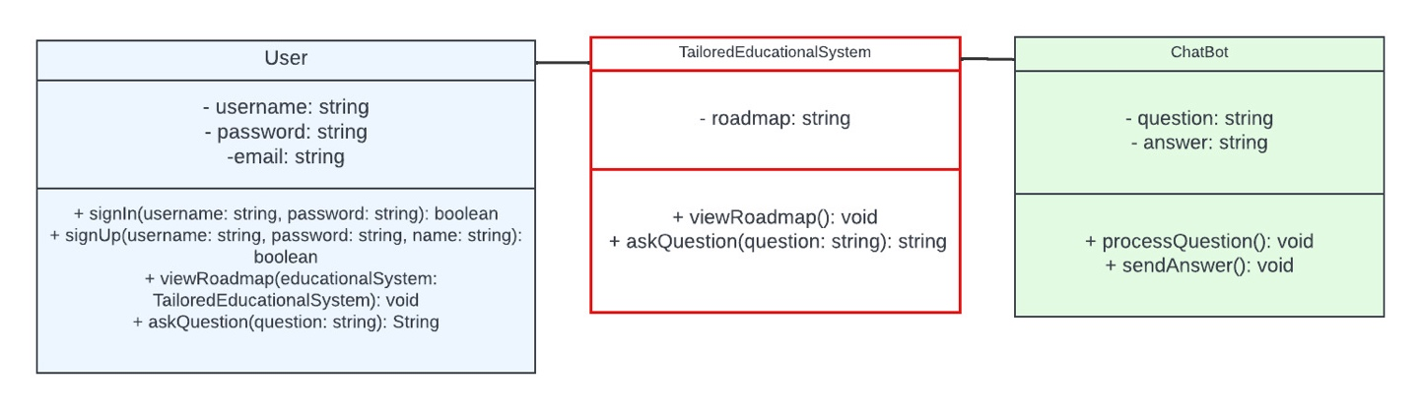

* **Sequence Diagrams:**

**Register interface:**

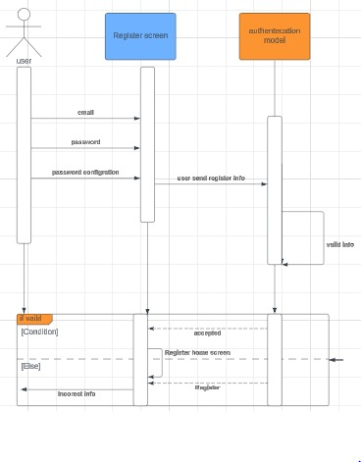

**Login interface:**

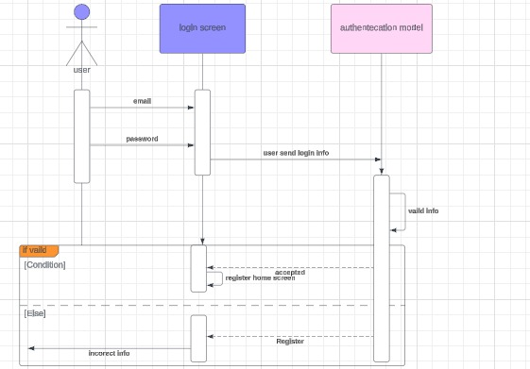

* **User interface:**

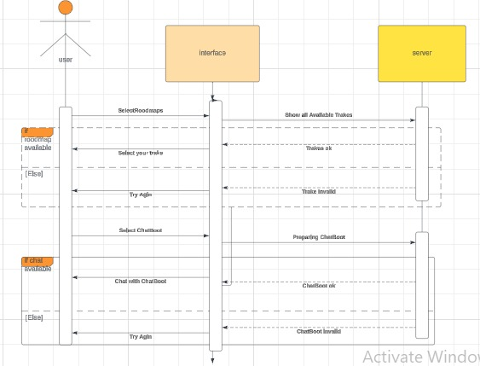

# Background/Related Work

## 2.1 Machine learning (ML):

Machine learning is a type of artificial intelligence that involves the development of algorithms and statistical models that enable computers to learn from data, without being explicitly programmed. Artificial intelligence (AI) applications such as machine learning enable systems to automatically learn from their experiences and advance without explicit programming. The goal of machine learning is to enable computers to automatically improve their performance on a specific task over time, by learning from experience, machine learning enables users to send massive amounts of data into computer algorithms, which then analyses, recommend, and decide using only the input data.In machine learning, computers are trained on large amounts of data to recognize patterns and relationships, and then use this knowledge to make predictions or decisions about new data. Machine learning has a wide range of applications, including image and speech recognition, natural language processing, detection, recommendation systems, and autonomous vehicles, among others. There are different types of machine learning:supervised learning, unsupervised learning, and reinforcement learning are the three primary categories of machine learning.

**2.2 NLP:**

Natural language processing (NLP) is a branch of [artificial intelligence (AI)](https://www.oracle.com/eg/artificial-intelligence/what-is-ai/) that enables computers to comprehend, generate, and manipulate human language. Natural language processing has the ability to interrogate the data with natural language text or voice. This is also called “language in.” Most consumers have probably interacted with NLP without realizing it. For instance, NLP is the core technology behind virtual assistants, such as the Oracle Digital Assistant (ODA), Siri, Cortana, or Alexa. When we ask questions of these virtual assistants, NLP is what enables them to not only understand the user’s request, but to also respond in natural language. NLP applies both to written text and speech and can be applied to all human languages. Other examples of tools powered by NLP include web search, email spam filtering, automatic translation of text or speech, document summarization, sentiment analysis, and grammar/spell checking. For example, some email programs can automatically suggest an appropriate reply to

a message based on its content—these programs use NLP to read, analyze, and respond to your message.

**2.3 Problems:**

Confusion in choosing a learning path for one of the programming fields

Many students face difficulties when deciding to learn programming they ask themselves which track to start?

How to start?

What can I achieve at the end of my path?

Which resources to learn? Don’t worry Chatbot will answer your questions.

**Chapter Three**

**Collection and employing data**

**3.1 Collect Data:**

* We collected data from many websites and searched for a lot of information, the information that we searched about it included research into various purview.
* Data collected about many Tracks which pertains to the field of programming.

**3.2 We collected the data in these tracks:**

* **Android Developer**
* **Full Stack Developer**
* **Back End Developer**
* **Front End Developer**
* **Flutter Developer**
* **Ai and Data Sciences**
* **UI / UX Developer**

**3.3 The data collected for two Function in website and application these functions are:**

* **Rood Maps**
* **Search about a question**

**3.3.1 The data collected in the Android Track:**

We collected data about Android track so that we can use it in two ways function (roadmap and search about question).

* **In Roadmap:**

We have collected all the questions and information on the track, so that it contains all the data, so that the first time a person enters the track, he can learn everything and become a professional in the track.

* **search about question:**

We collected all the data in the form of a question and answer, created questions with their answers, put them in a word file, then converted them to a Json file so that we could use them in the model we created.

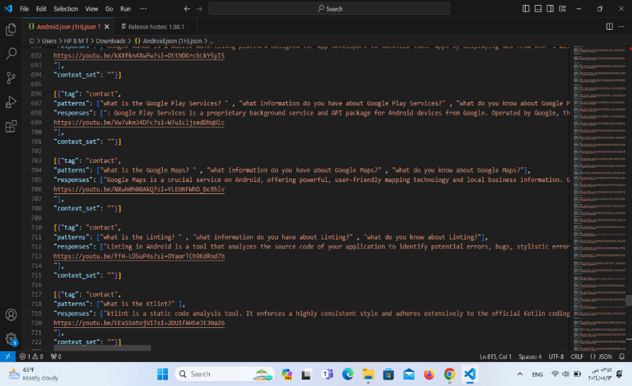

**3.3.2 The data collected in the flutter Track:**

We collected data about flutter track so that we can use it in two ways function roadmap and search about question.

* **Function Roadmap:**

We collected the data in the form of questions at each point in the track, so that the person learns it from zero until he becomes perfect in this track.

* **Function search about question:**

We collected the data in the form of a question and answer, we wrote them in a word file and converted them to a Json file so that we could use them in the model that we made.

.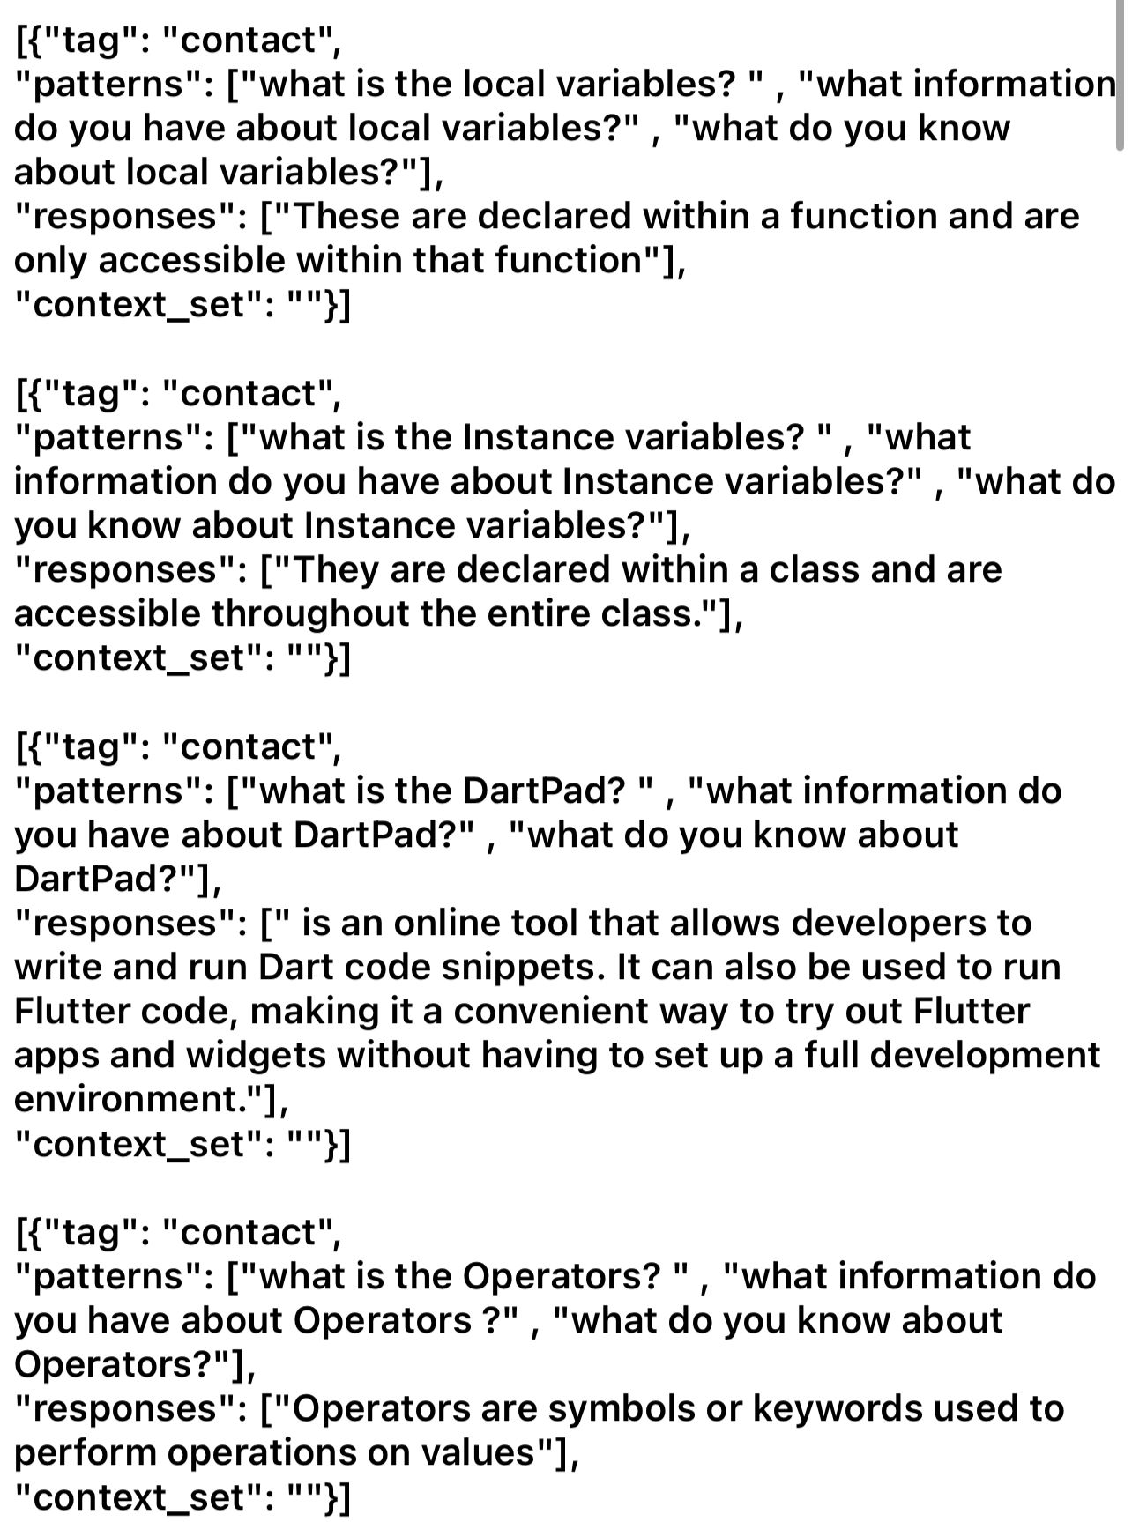

**3.3.3 The data collected in the back-end Track:**

We collected the data of the backend track so that we can use it in two functions (roadmap, search about a questions).

* **Road map Function:**

We collected the questions so that every point in backend track would be able to be learned by the person and benefit from it. We collected everything related to the track so that the person would have knowledge of everything in the track, from zero to being perfect on this track.

* **Search about a questions function:**

We collected the data in the form of a question and answer. We proposed these questions and answers, created them in a Word file, then converted them to a JSON file so that we could use them in the model we made.

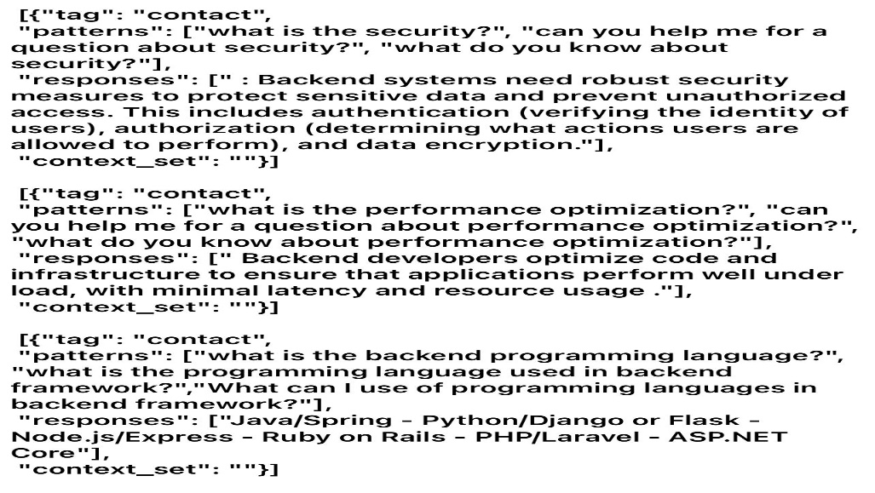

**3.3.4 The data collected in the Ai and Data science Track:**

We collected data about Ai and Data science track so that we can use it in two ways function roadmap and search about question.

* **Roadmap Function:**

We collected the data in the form of questions at each point in the track, so that the person learns it from zero until he becomes perfect in this track

* **Function search about question:**

we collected the data in the form of a question and answer, we wrote them in a word file and converted them to a Json file so that we could use them in the model that we made.

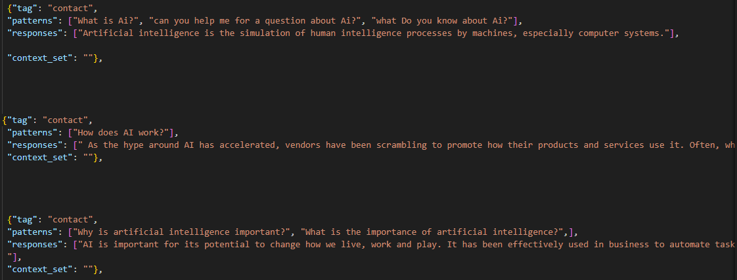

**3.3.5 The data collected in the full stack Track:**

We collected the data of the full stacktrack so that we can use it in two functions (roadmap, search about a questions).

* **Road map Function:**

We collected the questions so that every point in full stack track would be able to be learned by the person and benefit from it. We collected everything related to the track so that the person would have knowledge of everything on the track, from zero to being perfect on this track.

* **search about a questions function:**

We collected the data in the form of a question and answer. We proposed these questions and answers, created them in a Word file, then converted them to a JSON file so that we could use them in the model we made.

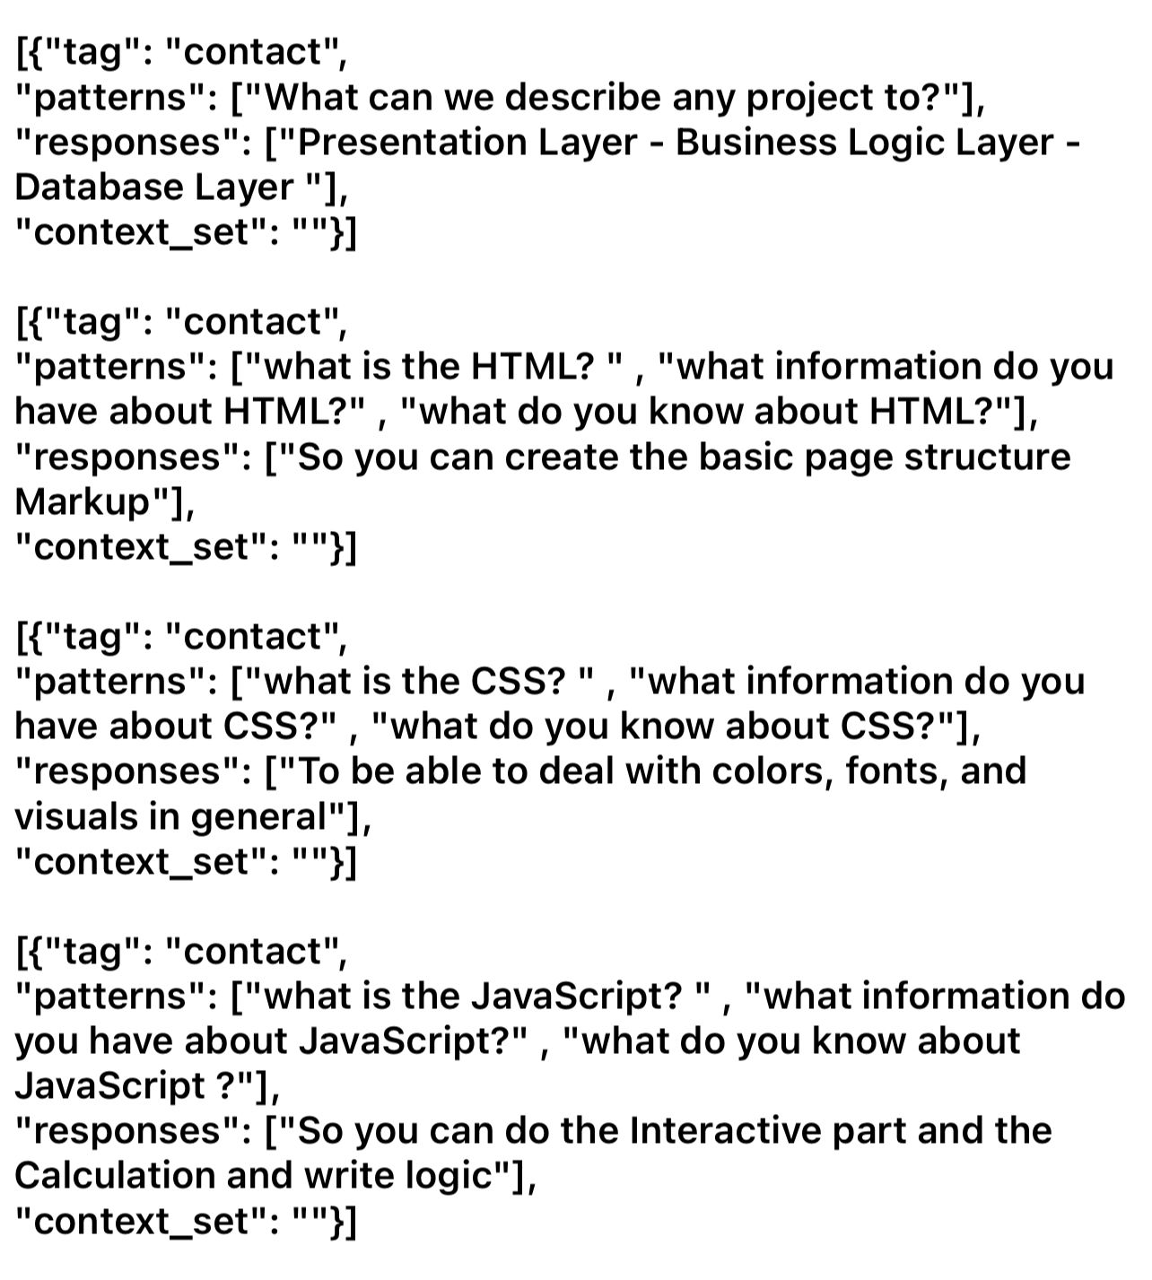

**3.3.6 The data collected in the front-end Track:**

We collected the data of the front-endtrack so that we can use it in two functions (roadmap, search about a questions).

* **Road map Function:**

We collected the questions so that every point in front-end track would be able to be learned by the person and benefit from it. We collected everything related to the track so that the person would have knowledge of everything on the track, from zero to being perfect on this track.

* **search about a questions function:**

We collected the data in the form of a question and answer. We proposed these questions and answers, created them in a Word file, then converted them to a JSON file so that we could use them in the model we made.

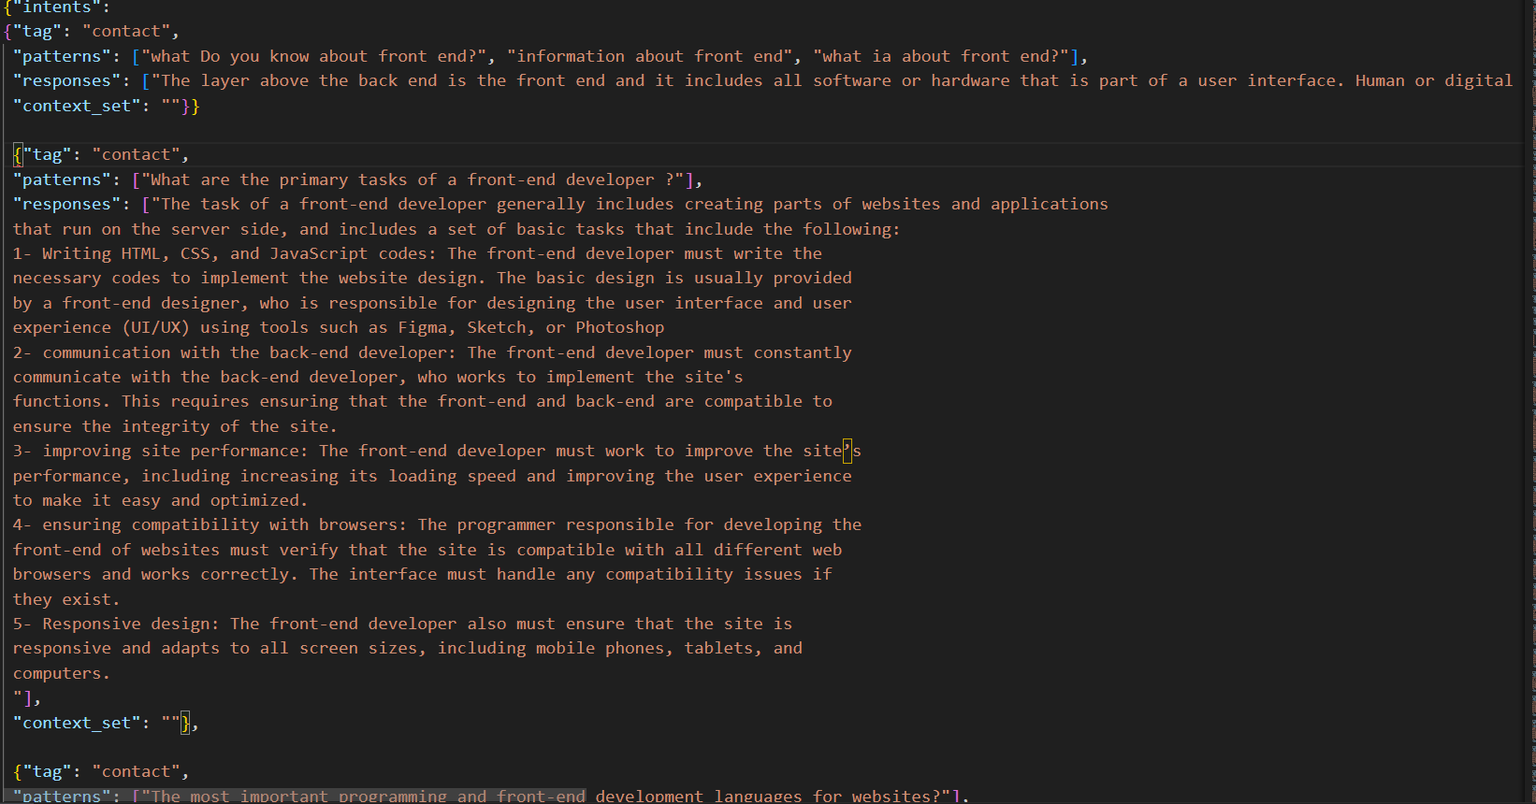

**3.3.7 The data collected in the Ui/Ux Track:**

We collected data about Ui/Ux track so that we can use it in two ways (roadmap and search about question).

* **Roadmap Function:**

We have collected all the questions and information on the track, so that it contains all the data, so that the first time a person enters the track, he can learn everything and become a professional on the track.

* **Search about a question function:**

We collected all the data in the form of a question and answer, created questions with their answers, put them in a word file, then converted them to a Json file so that we could use them in the model we created.

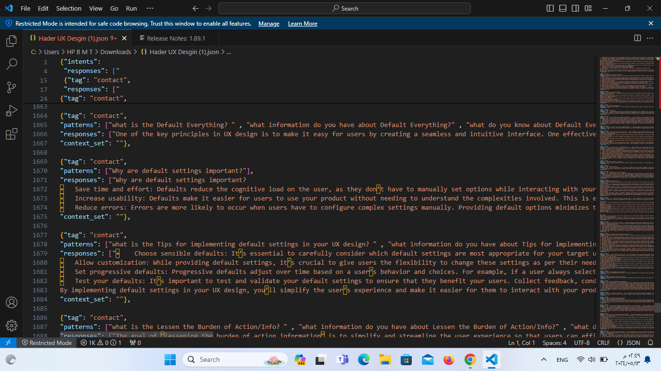

**Chapter Four**

# Chatbot (Machine learning model ,NlP and deployment)

## 4.1 Main core of the project:

In this phase we divide all the data we have into training, test, and validation. First train our model using 80% of the dataset we collected from the many websites we visited. Then we can tell users about a suitable track for him to learn. using our application.

**4.2 Chatbots and Virtual Assistants:**

Through the training we have a huge amount of data, Providing human-like interactions for customer service, information retrieval, and more.

### 4.2.1 Supervised Classification:

In building a chatbot using supervised pattern recognition with Natural Language Processing (NLP), the goal is to leverage NLP techniques to process and understand natural language inputs for effective classification. Here's a step-by-step approach to using supervised classification with NLP in chatbots:

1- **Data Collection and Preprocessing**

2 - **Feature Extraction with NLP**

3 - **Model Selection**

**4 - Training the Model**

**5 - Integration into Chatbot**

**6 - Response Generation**

### 4.2.2 Unsupervised Classification:

Unsupervised classification in the context of chatbots involves using techniques to classify or group similar data without labeled training examples. Instead of relying on labeled data, unsupervised learning methods aim to discover patterns, structures, or similarities within the data itself. Here's how unsupervised classification can be applied in chatbots:

**1-Clustering Techniques**

**2- Word Embeddings and Similarity Measures:**

**3- Anomaly Detection:**

**4- Response Generation or Routing:**

**5- Continuous Learning and Improvement:**

### 4.2.3 Structure for performing NLP in chatbots:

### 1. Text Preprocessing:

* **Tokenization:** Break down the input text into smaller units (tokens), usually words or sub words.
* **Lowercasing:** Convert all text to lowercase to standardize input.
* **Removing Stop words:** Eliminate common words that do not carry significant meaning (e.g., "and" "the," "is").
* **Stemming/Lemmatization:** Reduce words to their root form for normalization (e.g., "running" to "run").

### 2. Intent Recognition and Entity Extraction:

* **Intent Classification:** Identify the purpose or intention behind the user's input (e.g., asking for information, placing an order).
* **Named Entity Recognition (NER):** Extract relevant entities like names, dates, locations, etc., from the user's input that might be needed for further processing.

### 3. Dialog Management:

* **State Management:** Keep track of the conversation context, such as maintaining information from previous interactions to provide continuity.
* **Response Generation:** Generate appropriate responses based on the recognized intent, extracted entities, and the chatbot's knowledge base.

### 4. Natural Language Understanding (NLU) Models:

* Utilize various NLP models like word embeddings, Tokenization, synonym replacement for understanding user input, context, and generating responses.

### 5. Context Handling and Memory:

* Maintain a memory or context of the conversation to provide more personalized and contextually relevant responses.
* Handle multi-turn conversations effectively by recalling past interactions.

### 6. Sentiment Analysis (Optional):

* Perform sentiment analysis if necessary to understand the emotional tone of the user's input or to gauge sentiment towards a product/service.

### 7. Integration and Deployment:

* Integrate the NLP components into the chatbot framework.
* Deploy the chatbot on the desired platform (e.g., website, messaging apps).

### 8. Continuous Improvement:

* Collect user feedback and interaction data to improve the chatbot's performance.
* Fine-tune the NLP models with additional training data or retraining for better accuracy and understanding.

### Tools and Libraries:

Utilize NLP libraries and frameworks like NLTK and Sklearn for implementing various NLP tasks effectively within the chatbot structure.

This structured approach provides guidelines for incorporating NLP into chatbots. The specific implementation might vary based on the chatbot's goals, target audience, and the complexity of the interactions it needs to handle. Continuous iteration and improvement based on user feedback are essential for creating a successful NLP-powered chatbot.

### 4.2.4 Choosing from the Natural Language Processing Algorithms:

**Tokenization (one of NLP algorithms):**

Algorithms that segment text into tokens such as words, sentences, or characters. Examples include simple white-space tokenization, regular expressions, and more advanced methods like the Treebank tokenizer.

#### 4.2.4.1 Training the model

**Training the Model (supervised):**

Split the dataset into training and validation sets.

Feed the preprocessed text data along with their labels into the selected model for training.

Adjust hyperparameters and fine-tune the model to optimize performance.

**4.3 Machine Learning Types**

1. **Supervised Learning:**

In supervised learning, a labelled dataset is used to train the computer, and the input data and corresponding output labels are linked. Learning a function that translates input data to the appropriate output labels is the aim of supervised learning. Common applications of this kind of learning include classification and regression. Supervised machine learning is a type of machine learning where the computer is trained on a labeled dataset, where each example in the dataset consists of an input feature vector and a corresponding output label. The goal of supervised learning is to learn a function that maps the input feature vector to the correct output label. The process of supervised learning can be broken down into two stages: training and prediction. During the training stage, the computer uses the labeled examples in the dataset to learn the function that maps the input to the output.

1. **Unsupervised Learning**

In unsupervised learning, the computer is trained on a dataset that has no labels assigned to the data inputs, resulting in unsupervised learning. Unsupervised learning seeks to identify links and patterns in data without any prior knowledge of the intended outcome. dimension and clustering

Unsupervised learning has a wide range of applications, including anomaly detection, data compression, and recommendation systems, among others.

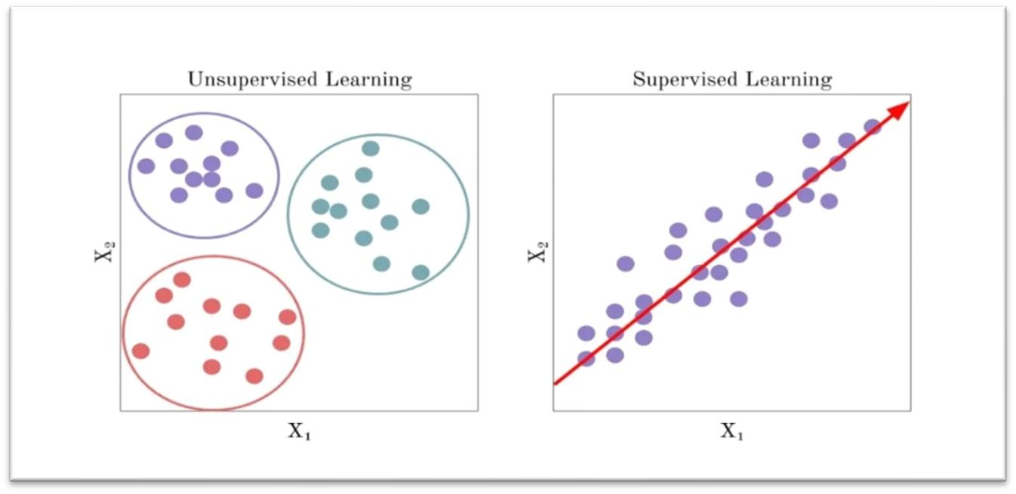

1. **Semi-supervised learning:**

Semi-supervised learning is a type of machine learning in which a model learns from both labeled and unlabeled data. In traditional supervised learning, a model is trained on a dataset where all the data points are labeled with their corresponding correct output.

The basic idea of semi-supervised learning is to use the labeled data to guide the learning process and use the unlabeled data to learn more general patterns or relationships in the data. The model can then use this knowledge to make better predictions on new, unseen data.

semi-supervised learning uses a combination of supervised and unsupervised learning algorithms. The supervised algorithm is used to learn from the labeled data, while the unsupervised algorithm is used to learn from the unlabeled data. The two algorithms are then combined to create a more accurate model.

Semi-supervised learning has been successfully applied in various fields, such as natural language processing, computer vision, and speech recognition, where obtaining labeled data can be difficult or expensive.

**d) Reinforcement Learning**

In reinforcement learning, the computer learns by interacting with an environment and receiving feedback in the form of rewards or penalties. The goal of reinforcement learning is to learn a policy that maximizes the expected cumulative reward over time. This type of learning is commonly used in tasks such as game playing and robotics. There are also other types of machine learning, such as semi-supervised learning, transfer learning, and deep learning, which are variations or combinations of the three main types mentioned above.

**4.4 Implementation of the machine learning model**

**4.4.1 Loading Intents for training the model:**

**• Intent Object:**

* Each intent object has the following key-value pairs:
  + "tag": A unique identifier or label for the intent. This is used to associate patterns and responses with the corresponding intent.
  + "patterns": A list of user inputs (patterns) that are associated with the intent. These are examples of what users might say to convey this intention.
  + "responses": A list of responses that the chatbot can provide when it detects this intent in the user's input. These responses are chosen based on the detected intent and are used to generate the chatbot's reply.

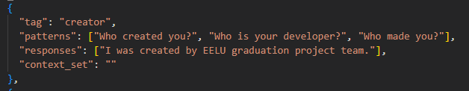

* **Usage:**
* This structured data can be used for training machine learning models to recognize user intents based on their input text. It forms the training data for the model, where inputs (patterns) are associated with corresponding labels (intents).
* During inference, when a user inputs a message, the chatbot can use a trained model to predict the intent of the message and select an appropriate response from the responses associated with that intent.

**4.4.2 Synonym Replacement Function (synonym replacement)**:

* This function is designed to perform synonym replacement on a list of tokens.
* Parameters:
  + tokens: The list of tokens representing a sentence.
  + limit: The maximum number of synonym replacements to perform for each token.
* It iterates through each token in the input list and retrieves synonyms using WordNet, a lexical database for the English language.
* If synonyms are found for a token, it randomly samples a subset of synonyms (up to the specified limit) and replaces the token with each synonym to generate augmented sentences.
* Finally, it returns a list of augmented sentences.

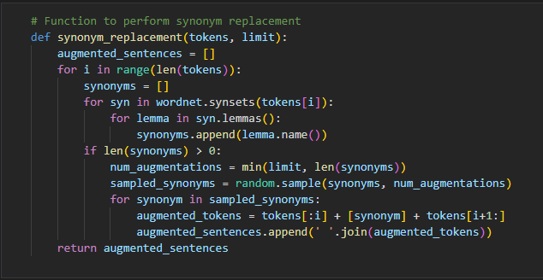

**4.4.3 Augmentation of data:**

**Data Augmentation Loop:**

* The code iterates through each intent in the intents dictionary.
* For each intent, it iterates through each example sentence (pattern) in the 'patterns' list.
* It tokenizes each example sentence into words, converts them to lowercase, and filters out stop words and non-alphabetic tokens.
* If the resulting list of filtered tokens is not empty, it adds the preprocessed sentence to text_data and its corresponding label to labels.
* It then performs synonym replacement using the synonym_replacement function to generate augmented sentences. These augmented sentences are also added to text_data, along with their corresponding labels.
* The loop continues until the desired limit (limit_per_tag) of augmented sentences per tag is reached.

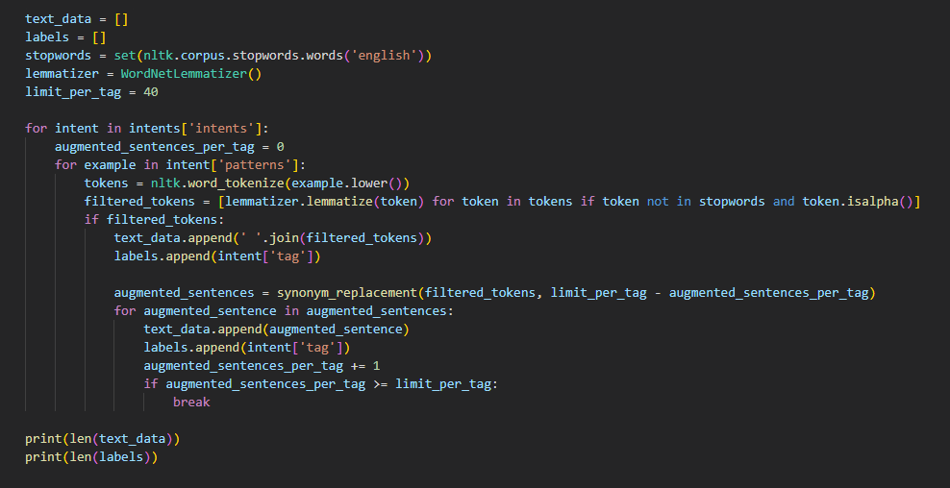

This code snippet demonstrates a technique for data augmentation in natural language processing (NLP) tasks using synonym replacement. It aims to increase the diversity of training data to improve the performance of machine learning models, particularly in scenarios with limited training data. The augmented data can help the model generalize better and capture a wider range of variations in input text.

After augmentation we can notice that the length of data has been increased although the limited intents that we provided for the model

**4.4.4 Finding Best Model using (**Grid Search CV):

This function, find_best_model, is designed to find the best-performing machine learning model among a set of candidates for a given dataset. Here's an explanation of how it works:

* **Data Splitting**:
  + The function splits the input data (X, features, and y, labels) into training and testing sets using the train_test_split function from scikit-learn. By default, it allocates 20% of the data for testing and uses a fixed random state for reproducibility.
* **Model Selection**:
  + The function defines a list of candidate models along with their hyperparameter grids for tuning. The models include Logistic Regression, Multinomial Naive Bayes, Linear SVC, Decision Tree, and Random Forest.
  + For each model, it performs hyperparameter tuning using grid search (Grid Search CV), which exhaustively searches over specified parameter values and uses cross-validation (with 3 folds) to find the best combination of hyperparameters that maximizes model performance.
  + After tuning, it evaluates each model's performance on the test set and prints the accuracy score along with the best hyperparameters found during grid search.
* **Best Model Selection**:
  + Once all models have been trained and evaluated, the function selects the best-performing model based on the highest accuracy score achieved on the test set.
  + It prints the name of the best model along with its accuracy score and best parameters.
* **Final Model Fitting**:
  + The best model is fitted to the full training dataset (including both training and testing portions) before returning it.
* **Output**:
  + The function returns the best-performing model, which can be further used for making predictions on new data.

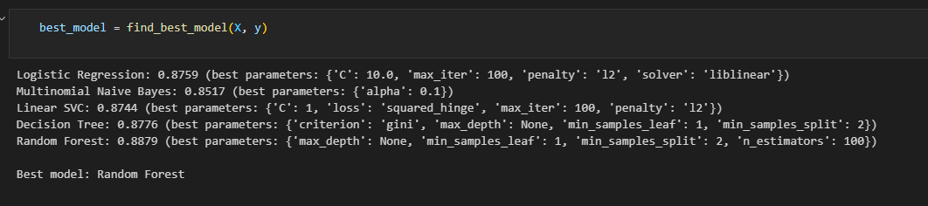

Therefore, the best model identified by the find_best_model function is the Random Forest classifier with the specified hyperparameters.

Random Forest model achieved the highest accuracy score of 0.8879 on the test set, making it the best-performing model for the given dataset

4.4.5 Saving the model and getting ready for deployment

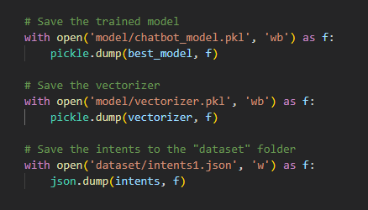

# 4.5 Chatbot Deployment

## Overview

This document provides instructions for deploying a chatbot model to Flask. The chatbot is trained to understand user intents and provide appropriate responses based on the trained model. The deployment allows users to interact with the chatbot via a web interface and an API endpoint.

## Requirements

* **Python (3.x)**
* **Flask**
* **scikit-learn**
* **pickle**
* **Json**

## Setup Instructions

* Install the required Python packages using pip:
* pip install Flask scikit-learn
* Place the trained model (chatbot_model.pkl), vectorizer (vectorizer.pkl), and intents data (intents1.json) in the appropriate directories (model and dataset).
* Ensure that the Flask application is configured correctly to load the model and vectorizer during runtime.

### API Endpoint

* The chatbot also provides an API endpoint for programmatic interaction.
* Send a POST request to <http://localhost:5000/api/chat> with a JSON payload containing the user input:

**Json**

{  
 "user_input": "Your message here"  
}

* The API will respond with a JSON object containing the chatbot's response:

**Json**

{  
 "response": "Chatbot's response here"  
}

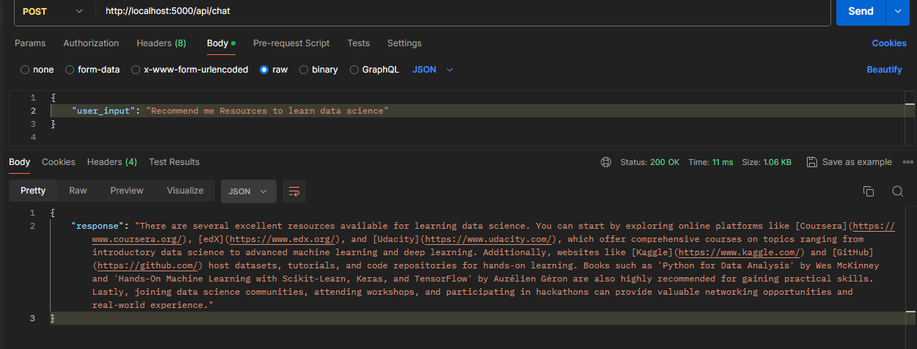

## Code Explanation

* The Flask application (app.py) loads the trained model, vectorizer, and intents data during initialization.
* The chatbot_response function processes user input, predicts the intent using the model, and selects a response from the intents data.

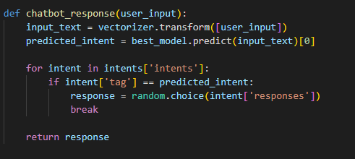

* **The /chat route handles user interactions via the web interface, while the /api/chat route serves as the API endpoint for programmatic interactions.**

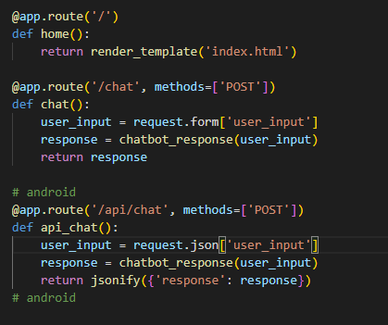

Now chatbot model is fully deployed and ready to use for both the android app and the web, the flask app is running on local host where it can receive POST requests to send and receive JSON text

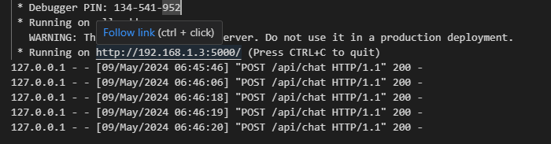

**Chapter Five**

# Result and Discussion

## 1. Introduction

In this chapter, we delved into the details of these **Two** approaches to help students by providing them with information belonging to the learning.

**The first method** involves students can see all the rood maps and collecting much information about any track to learn how to start until they become hero in the track.

**The second method** Students can search for any information belonging to the learning such as: "How make API “, “How make Recycler view “.

All methods provide convenient ways to gather data of the students, which is then processed through various techniques. These approaches allow enthusiasts and researchers to get all information that they want in an easy way.

**Our website:**

* + **Sign In Page**

The login screen is a secure gateway to access a system or application. It typically prompts users to enter their credentials, such as a username and password, ensuring only authorized individuals gain entry. This initial authentication step plays a crucial role in safeguarding digital assets and user privacy.

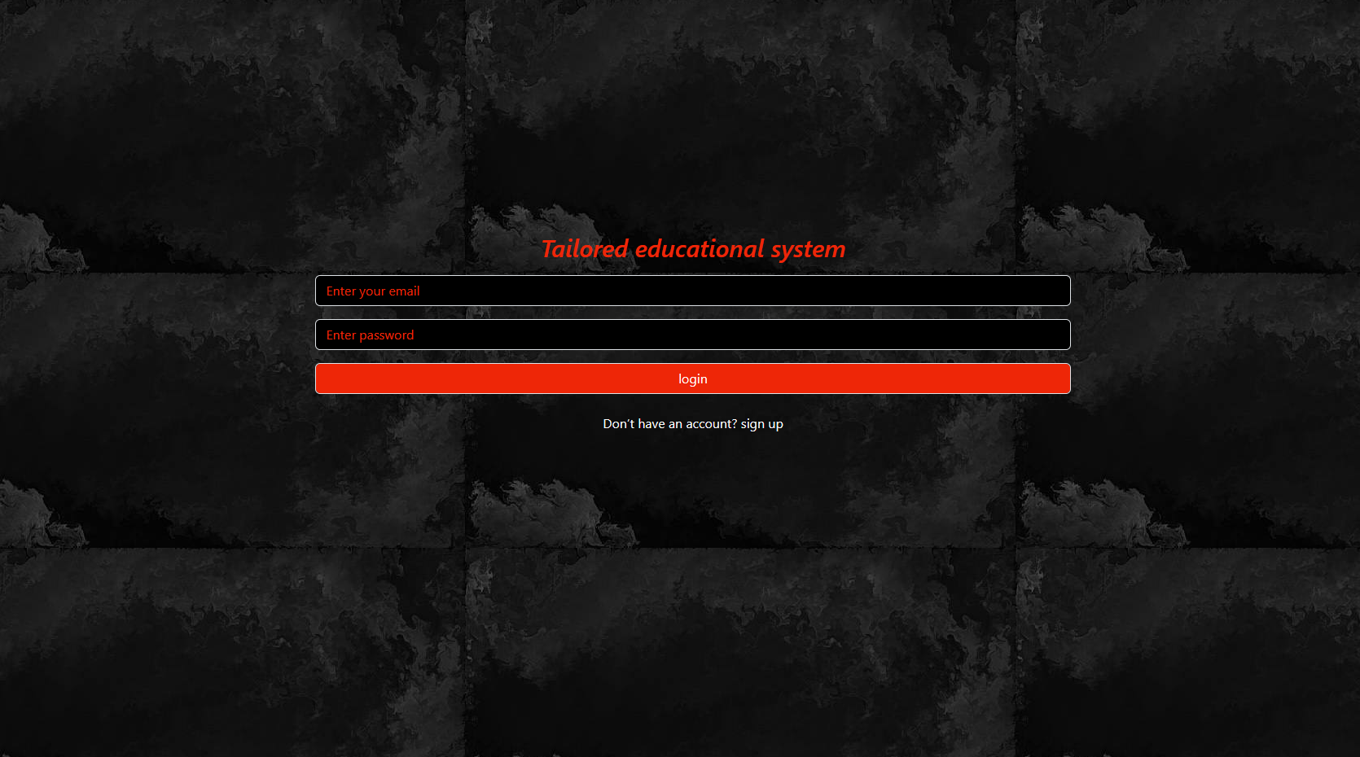

* **Sign-up Page**

The sign-up page is a registration portal where users create new accounts to access a system or service. It usually involves providing essential information, like a username, email, and password. This process allows users to establish their identity within the platform, enabling personalized experiences and secure interactions.

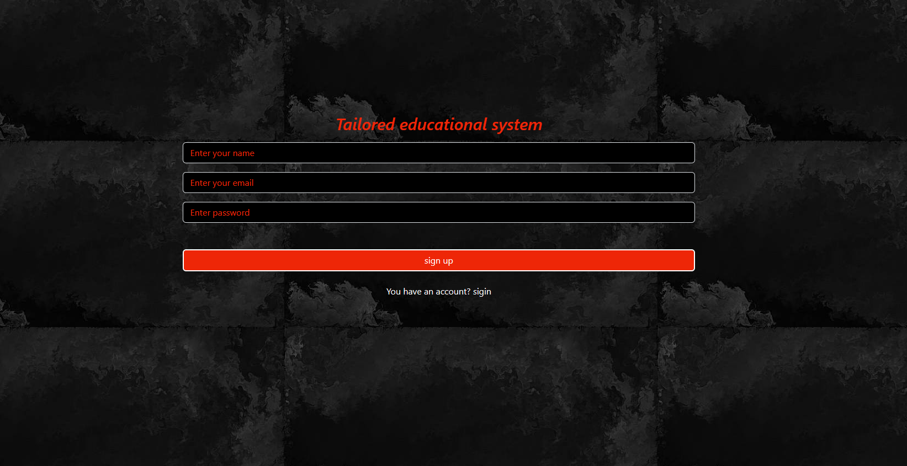

* + **About Page:**

This About page servers as a concise overview of our website, we are an integrated educational website that makes it easy for students or researchers to quickly reach what they are looking for without distraction or a long time by talking to a chatbot or searching through our website.

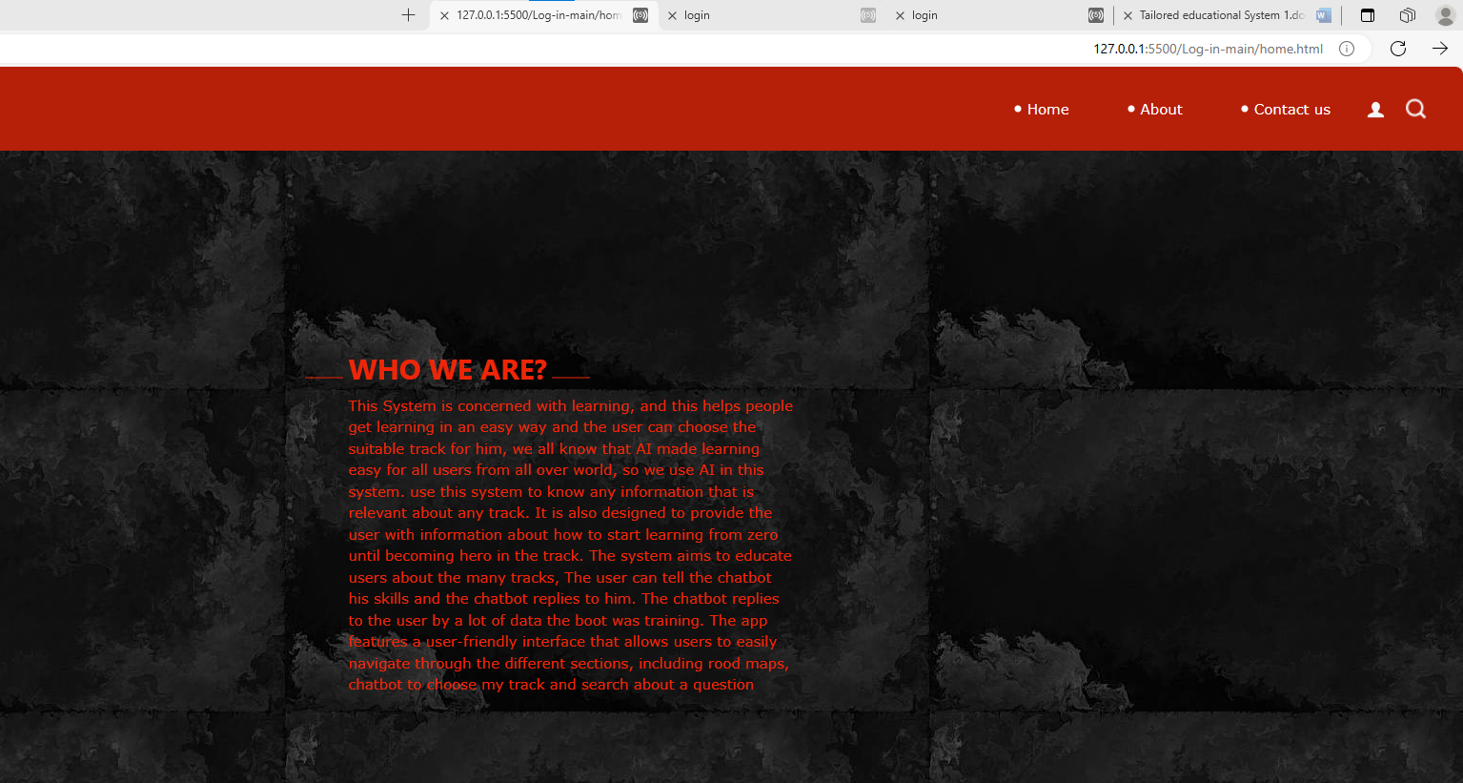

* **Home Page**

### This screen is the most critical part of the application. In this screen, the user can do many tasks and navigate between them and there is a Settings panel.

### If the user wants to show all tracks they can click on the button of “Rood Maps”.

### If the user wants to chat to the chatbot to choose the suitable track for him can click on the button of “Choose my track”.

If the user wants to chat to the chatbot to search about any question related to learning can click on the button of **“Search about a question”.**

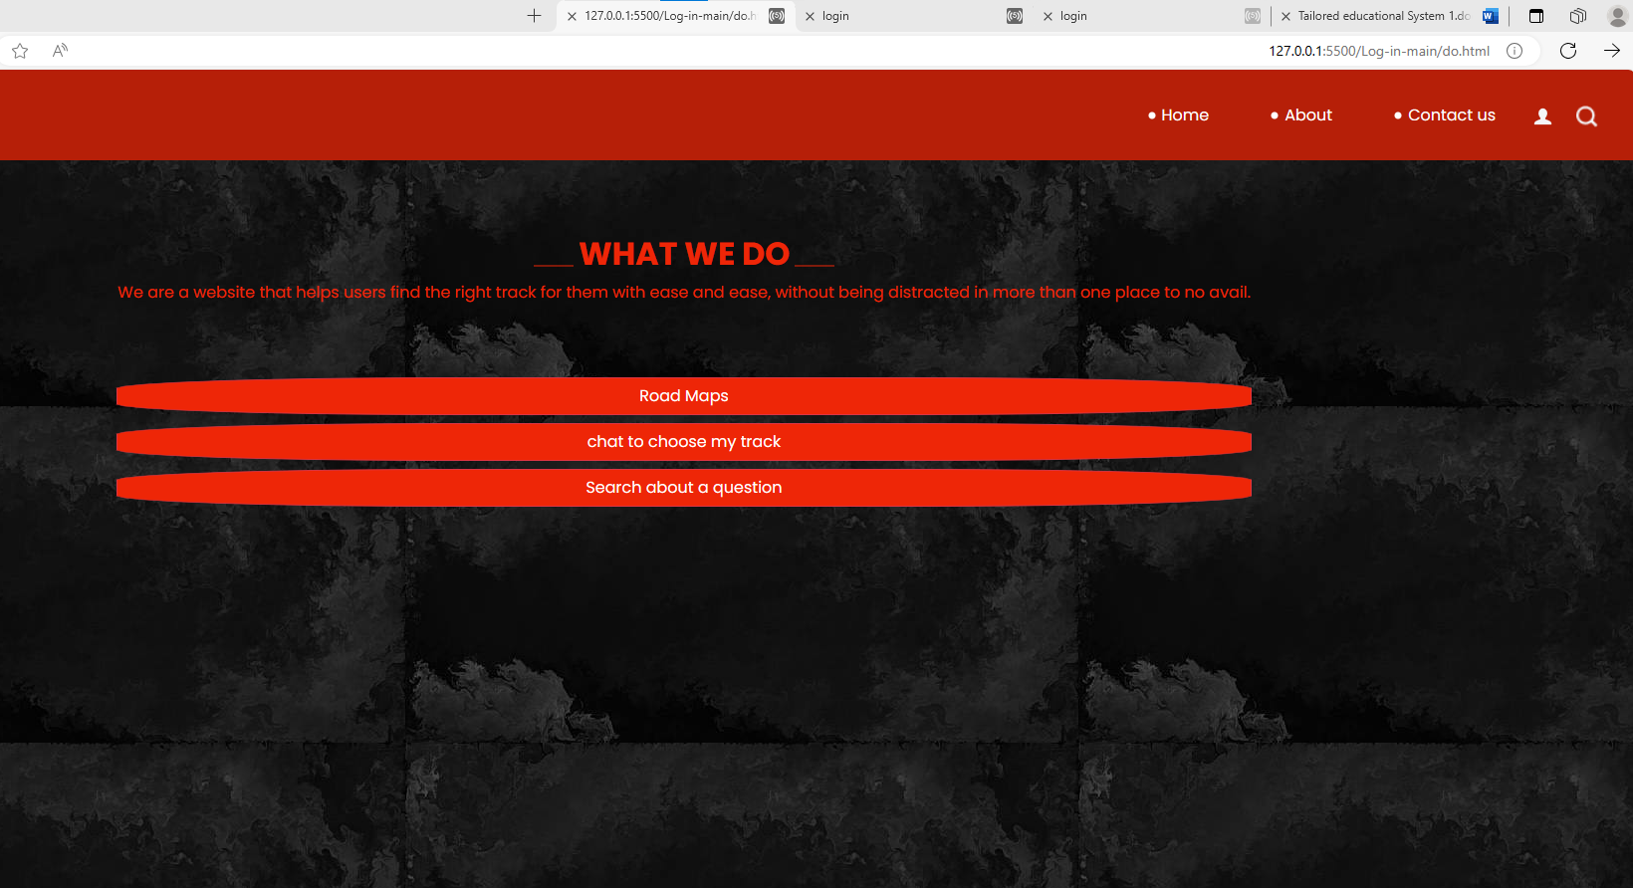

* **Road Maps Page**

The screen shows a set of tracks, the user can know any information that is relevant about any track.

The user can scroll in this screen and choose which track he wants to know about it.

The second screen provides information about the track that user chooses it.

This information is about how to start learning from zero until becoming a hero.

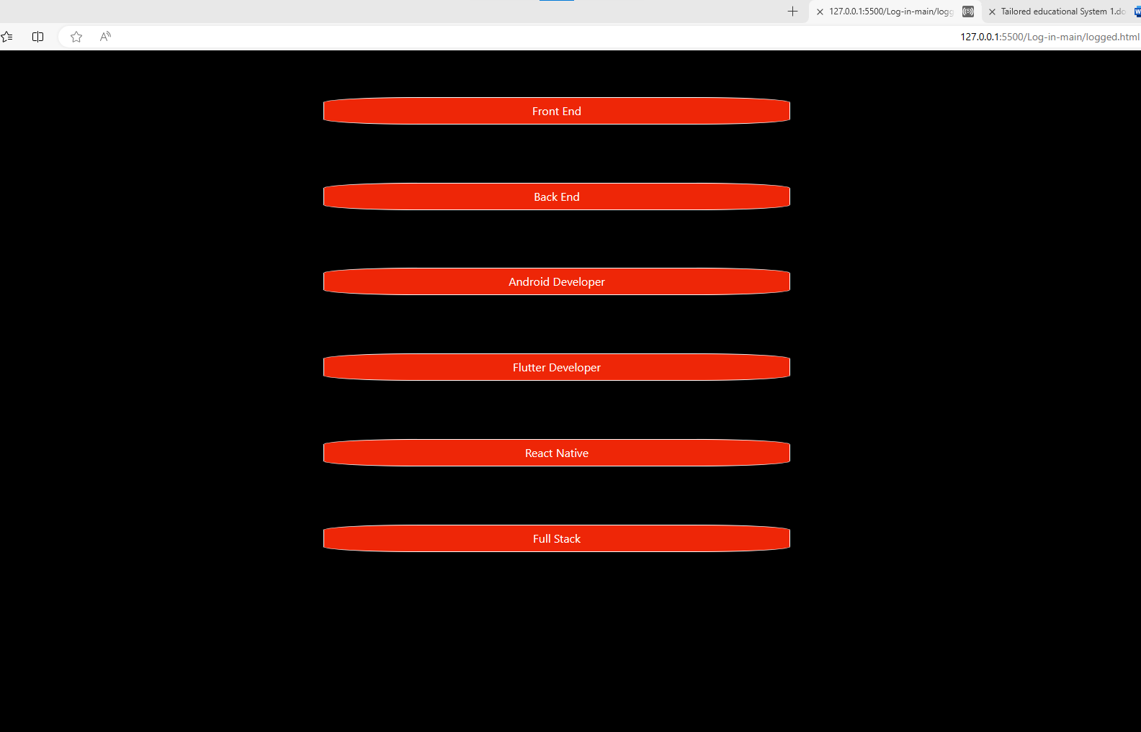

## Our App

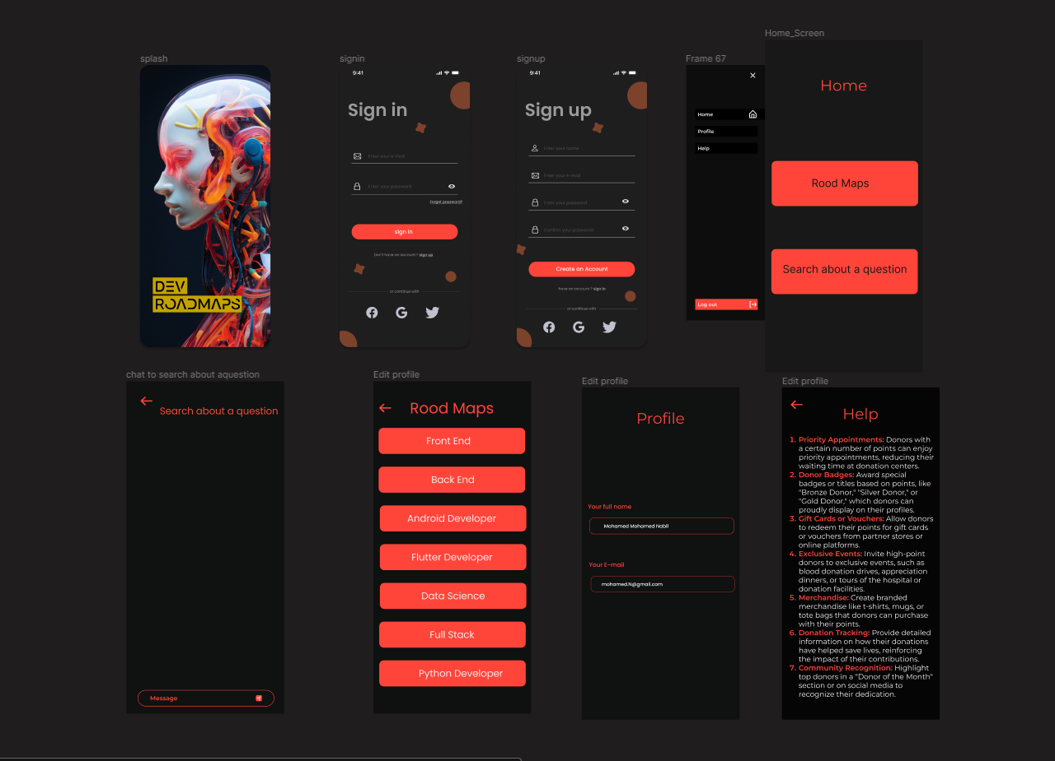

### Trello:

[**https://trello.com/invite/b/xdT6o2EB/ATTIa494fb15bb03bc9aa3a25bbef337026a6CE20746/neuron-seeking-learn**](https://trello.com/invite/b/xdT6o2EB/ATTIa494fb15bb03bc9aa3a25bbef337026a6CE20746/neuron-seeking-learn)

* **Splash Screen**

Upon launching the application, users will be greeted by the initial screen known as the "Splash Screen."

This screen serves as an introductory interface and is displayed to users for a maximum duration of five seconds.

Following the Splash Screen, the application transitions to the next screen, which is the "Sign Up screen."

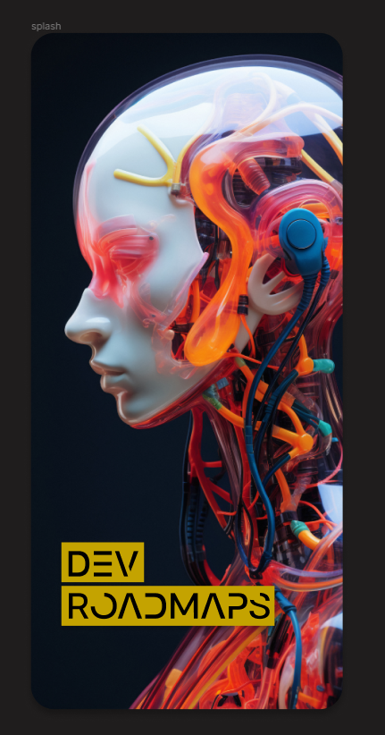

### Register Screen

Within this screen, users can create a new account within the application. To do so, they are prompted to input their name, personal email. Additionally, users are required to create a new password for their account. As a security measure, they are asked to confirm the password by entering it again. If the entered password does not match, a warning message will be displayed, notifying the user that the password is not identical.

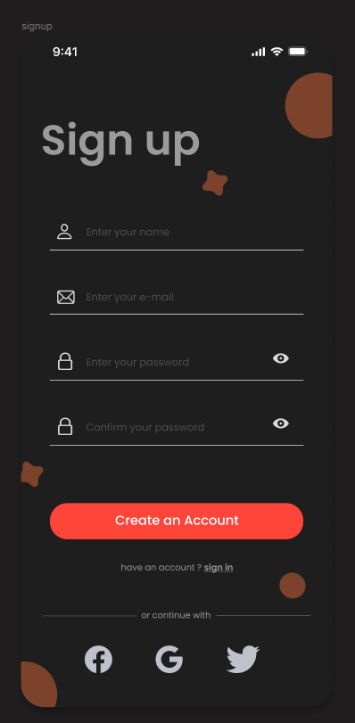

* **Sign in Screen**

can also Sign in using their Google or Facebook account. If the user chooses to log in using their Google or Facebook account, they will be directed to the relevant login page where they will need to enter their login credentials. Once they have successfully Sign in, they will be redirected back to the app and granted access.

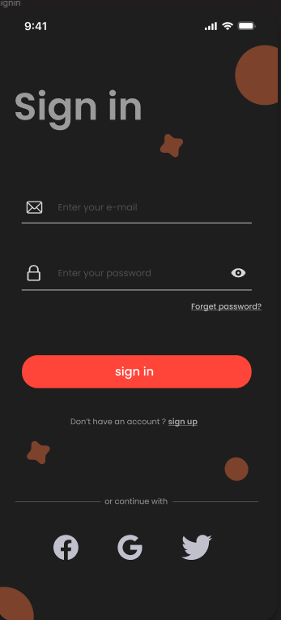

* **Home Screen:**

### This screen is the most critical part of the application. In this screen, the user can do many tasks and navigate between them and there is a Settings panel.

If the user wants to show all tracks they can click on the button of “Rood Maps”.

If the user wants to chat to the chatbot to search about any question related to learning can click on the button of “Search about a question”.

If the user wants to show and edit in his profile or show info about application and how to use it can click on the button off .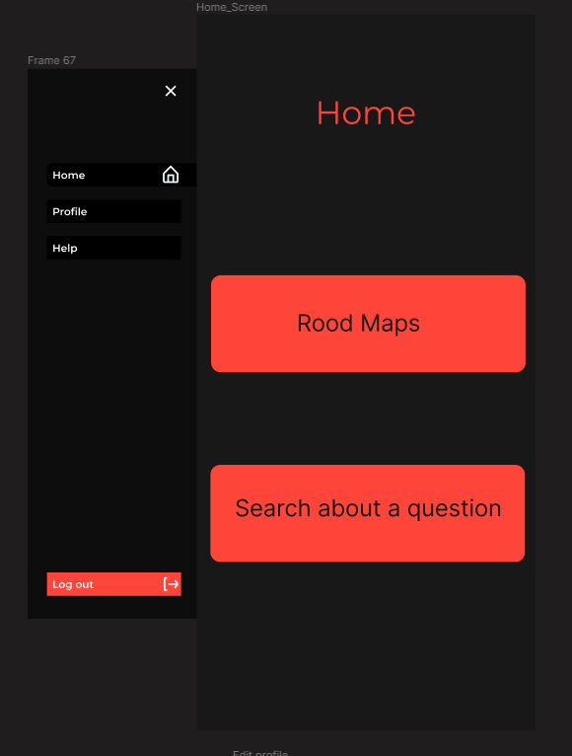

* **Rood Maps Screen**

The screen shows a set of tracks, the user can know any information that is relevant about any track.

The user can scroll in this screen and choose which track he wants to know about it.

The second screen provides information about the track that user chooses it.

This information is about how to start learning from zero until becoming a hero.

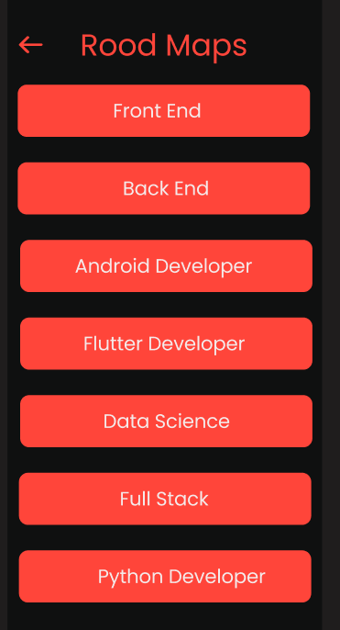

### Chat Screen

The screen is also designed to chat with the user and chatbot, it is aimed to answer any question belonging to the learning such as: "How make API “, “How make Recycler view “.

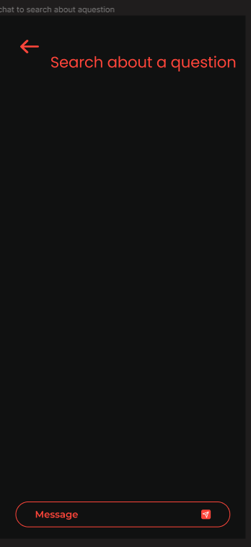

### Settings Screen

Settings panel, where you can go to the Profile screen and Help screen from it and log out too.

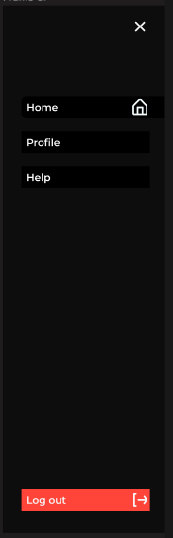

* **Info Screen**

The screen shows a set of information about how to use the Application and some information about the people who made this.

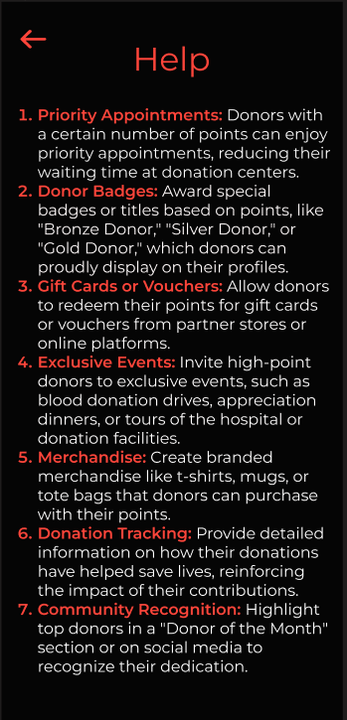

### Account Screen

The Account screen displays the user's personal details If the user wants to edit in his profile, including their username, personal email address and password.

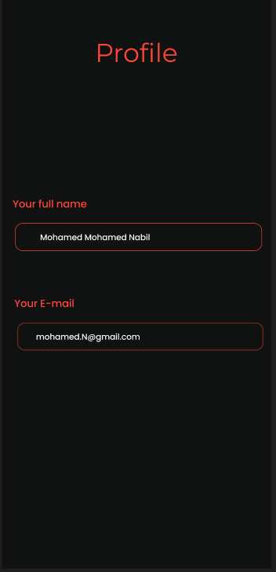

**Chapter Six**

# Conclusion and Future work

* **Conclusion:**

Now (AI) made learning easy for all users from all over world, so we intend to use this to made application and website to helps people get learning in an easy way and the user can choose the suitable track for him and provide the user with information about how to start learning from zero until becoming hero in the track.

The chatbot replies to the user by a lot of data the boot was training on it. The chatbot training on this data by Natural Language Processing (NLP) is a field of artificial intelligence (AI) that focuses on enabling computers to understand, interpret, and generate human language in a valuable and meaningful way.

Natural language processing has the ability to interrogate the data with natural language text , NLP is what enables them to not only understand the user’s request, but to also respond in natural language , and this help us in our app to make an interactive chatbot using (NLP)to answer users using data set to train model The Tailor Educational System Mobile Application is designed with scalability and continuous improvement in mind.

Machine learning is a type of artificial intelligence that involves the development of algorithms and statistical models that enable computers to learn from data, without being explicitly programmed.

Artificial intelligence (AI) applications such as machine learning enable systems to automatically learn from their experiences and advance without explicit programming. The goal of machine learning is to enable computers to automatically improve their performance on a specific task over time, by learning from experience.

Learning a function that translates input data to the appropriate output labels is the aim of supervised learning.

Common applications of this kind of learning include classification and regression. The app features a user-friendly interface that allows users to easily navigate through the different sections, including rood maps, chatbot to choose my track and search about a question.

**Future work:**

* In the future, we plan to develop a new version of our application and a website that will achieve high accuracy in choosing the track and answer about any question belonging to learning.
* We plan to add many tracks to our application and website.
* We plan to add another function called: (Choose suitable track).
* We plan to let the user do generate roadmaps with AI.

# References

* [**https://www.google.com/url?sa=t&rct=j&q=&esrc=s&source=web&cd=&cad=rja&uact=8&ved=2ahUKEwjXw47lp5KDAxUYXUEAHQToBT4QFnoECBAQAw&url=https%3A%2F%2Fwww.techtarget.com%2Fsearchenterpriseai%2Fdefinition%2Fnatural-language-processing-NLP&usg=AOvVaw0oTAa2yVLjn3uAKMfBDcCA&opi=89978449**](https://www.google.com/url?sa=t&rct=j&q=&esrc=s&source=web&cd=&cad=rja&uact=8&ved=2ahUKEwjXw47lp5KDAxUYXUEAHQToBT4QFnoECBAQAw&url=https%3A%2F%2Fwww.techtarget.com%2Fsearchenterpriseai%2Fdefinition%2Fnatural-language-processing-NLP&usg=AOvVaw0oTAa2yVLjn3uAKMfBDcCA&opi=89978449)
* [**https://www.geeksforgeeks.org/sklearn-model-hyper-parameters-tuning/**](https://www.geeksforgeeks.org/sklearn-model-hyper-parameters-tuning/)
* [**https://www.datacamp.com/tutorial/machine-learning-models-api-python?utm_source=google&utm_medium=paid_search&utm_campaignid=19589720824&utm_adgroupid=157156376311&utm_device=m&utm_keyword=&utm_matchtype=&utm_network=g&utm_adpostion=&utm_creative=698229374827&utm_targetid=aud-517318242147:dsa-2218886984100&utm_loc_interest_ms=&utm_loc_physical_ms=9112394&utm_content=&utm_campaign=230119_1-sea~dsa~tofu_2-b2c_3-row-p2_4-prc_5-na_6-na_7-le_8-pdsh-go_9-na_10-na_11-na-may24&gad_source=1&gclid=CjwKCAjwi_exBhA8EiwA_kU1MhjFjOz4Z4Az5VicnpDMEZIl8OdxPf7e_5j6ciyWqNS5Gd98wVjQtxoCaSwQAvD_BwE**](https://www.datacamp.com/tutorial/machine-learning-models-api-python?utm_source=google&utm_medium=paid_search&utm_campaignid=19589720824&utm_adgroupid=157156376311&utm_device=m&utm_keyword=&utm_matchtype=&utm_network=g&utm_adpostion=&utm_creative=698229374827&utm_targetid=aud-517318242147:dsa-2218886984100&utm_loc_interest_ms=&utm_loc_physical_ms=9112394&utm_content=&utm_campaign=230119_1-sea~dsa~tofu_2-b2c_3-row-p2_4-prc_5-na_6-na_7-le_8-pdsh-go_9-na_10-na_11-na-may24&gad_source=1&gclid=CjwKCAjwi_exBhA8EiwA_kU1MhjFjOz4Z4Az5VicnpDMEZIl8OdxPf7e_5j6ciyWqNS5Gd98wVjQtxoCaSwQAvD_BwE)
* [**https://www.geeksforgeeks.org/natural-language-processing-nlp-tutorial/**](https://www.geeksforgeeks.org/natural-language-processing-nlp-tutorial/)
* [**https://www.geeksforgeeks.org/natural-language-processing-nlp-tutorial/**](https://www.geeksforgeeks.org/natural-language-processing-nlp-tutorial/)
* [**https://roadmap.sh/.**](https://roadmap.sh/.)
* [**https://youtu.be/6XrL5jXmTwM?si=m9xPHJFZCO031JxI**](https://youtu.be/6XrL5jXmTwM?si=m9xPHJFZCO031JxI)
* [**https://youtube.com/playlist?list=PLnZgHKyxHOECUIYNG1_0QLzqUbZc2a5HN&si=yNDNWOWa-NTg5KOX**](https://youtube.com/playlist?list=PLnZgHKyxHOECUIYNG1_0QLzqUbZc2a5HN&si=yNDNWOWa-NTg5KOX)
* [**https://www.youtube.com/watch?v=yy-RPsffuKk&list=PLUDwpEzHYYLs6I6jA_USsP3UWfS7EKCf2**](https://www.youtube.com/watch?v=yy-RPsffuKk&list=PLUDwpEzHYYLs6I6jA_USsP3UWfS7EKCf2)